|  |
| --- |
|  |
| PRE-DETERMINATION OF PERFORMANCE CHARACTERISTICS OF A THREE PHASE INDUCTION MACHINE USING MATLAB |
| AC & SPECIAL MACHINES ASSIGNMENT-2 |
|  |

|  |
| --- |
| This is a program written using MATLAB, to pre-determine the performance of a three phase induction machine operated either as a generator or a motor. The only inputs required from the user are no-load and blocked-rotor test results, measured stator resistance. The behavior is analyzed at different slips of operation. |

**SUBMITTED BY-**

SAMBHAV R JAIN

107108103

PROGRAM CODE:

clc

clear all

close all

disp('This is a program that evaluates the performance characteristics of a three-phase induction machine from N.L. and B.R. test results');

fs=input('Enter the supplied frequency:');

P=input('Enter the number of poles created by the stator winding:');

Ns=120*fs/P;

s=0:0.001:0.18;

Nr=Ns*(1.-s);

ws=2*pi*Ns/60;

wr=2*pi.*Nr/60;

%Accepting data from the user:

V=input('Please enter the value of rated line voltage of the machine:\n');

a=menu('How is the stator of the machine connected?','Star','Delta');

if a==1

Vr=V/sqrt(3);

elseif a==2

Vr=V;

End

%To get the single phase equivalent circuit parameters from no-load %and blocked-rotor test results

Voc=input('Enter the no-load terminal voltage per phase:');

Ioc=input('Enter the no-load current per phase:');

Woc=input('Enter the no-load single phase wattmeter reading:');

Vsc=input('Enter the blocked-rotor terminal voltage per phase:');

Isc=input('Enter the blocked-rotor current per phase:');

Wsc=input('Enter the blocked-rotor single phase wattmeter reading:');

R1=input('Enter the measured stator resistance(a.c.) per phase:');

%No load parameter determination

pfoc=Woc/Voc/Ioc;

Iw=Ioc*pfoc;

Im=Ioc*sqrt(1-pfoc^2);

R0=Voc/Iw;

X0=Voc/Im;

%Blocked rotor parameter determination

Z01=Vsc/Isc;

R01=Wsc/Isc^2;

X01=sqrt(Z01^2-R01^2);

R2dash=R01-R1;

%Calculation

Rldash=R2dash*(1./s-1);

I2dash=Vr./(R01+Rldash+X01*i);

Z0=(R0*X0*i)/(R0+X0*i);

I0=Vr/Z0;

I1=I0+I2dash; %This is the total load current drawn per phase

Pir=3*(abs(I2dash).^2)*R2dash./s; %Three-phase power input to the %rotor

%abs returns the magnitude of a complex number)

Pd=3*(abs(I2dash).^2).*Rldash; %Total power developed

Td=Pir./ws; %Developed torque

Wm=3*(Woc/3); %Assuming 1/3rd of no-load losses is mechanical losses

%Woc is per phase, hence multiplying it by three

Wi=3*(Woc*2/3); %Assuming 2/3rd of no-load losses is iron losses

%Woc is per phase, hence multiplying it by three

Wcu1=3*(abs(I1).^2)*R1; %Stator copper losses

Po=Pd-Wm; %Total output power

Pi=Pir+Wcu1+Wi; %Total input power (three phase)

n=Po./Pi*100; %Efficiency

pf=(Pi/3)./(Vr*abs(I1));

%Plots

m=1;

while m~=2

k=menu('Choose:','Torque-Slip','Power-Slip','Speed-Torque','Slip-Output Power','Load current-Output Power','Speed-Output Power','Efficiency-Output Power','Power Factor-Output Power');

switch k

case 1

plot(s*100,Td);

grid on;

xlabel('% Slip,s ------>');

ylabel('Developed Torque,Td (N-m)------>');

title('Torque-Slip Characteristic');

case 2

plot(s*100,Pd);

grid on;

xlabel('% Slip,s ------>');

ylabel('Developed Power,Pd (W) ------>');

title('Power-Slip Characteristic');

case 3

plot(Td,Nr);

grid on;

xlabel('Developed Torque,Td (N-m) ------>');

ylabel('Speed,Nr (RPM) ------>');

title('Speed-Torque Characteristic');

case 4

plot(Po,s*100);

grid on;

xlabel('Output Power,Po (W) ------>');

ylabel('% Slip,s ------>');

title('Slip-Output Power Characteristic');

case 5

plot(Po,sqrt(3)*abs(I1));

grid on;

xlabel('Output Power,Po (W) ------>');

ylabel('Load current,I (A) ------>');

title('Load Current-Output Power Characteristic');

case 6

plot(Po,Nr);

grid on;

xlabel('Output Power,Po (W) ------>');

ylabel('Speed,Nr (RPM) ------>');

title('Speed-Output Power Characteristic');

case 7

plot(Po,n);

grid on;

xlabel('Output Power,Po (W) ------>');

ylabel('% Efficiency,n ------>');

title('Efficiency-Output Power Characteristic');

case 8

plot(Po,pf);

grid on;

xlabel('Output Power,Po (W) ------>');

ylabel('Power Factor,P.F. ------>');

title('Power Factor-Output Power Characteristic');

end

m=menu('Would you like to plot another characteristic?','Yes','No');

end

OUTPUT:

This is a program that evaluates the performance characteristics of a three-phase induction machine from N.L. and B.R. test results

Enter the supplied frequency:50

Enter the number of poles created by the stator winding:4

Please enter the value of rated line voltage of the machine:

415

Enter the no-load terminal voltage per phase:408

Enter the no-load current per phase:4.2/sqrt(3)

Enter the no-load single phase wattmeter reading:256/3

Enter the blocked-rotor terminal voltage per phase:85

Enter the blocked-rotor current per phase:7.5/sqrt(3)

Enter the blocked-rotor single phase wattmeter reading:620/3

Enter the measured stator resistance(a.c.) per phase:7.425

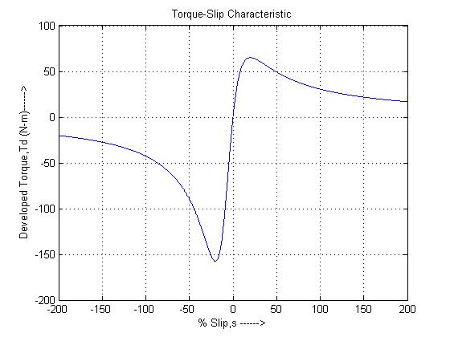PLOTS:

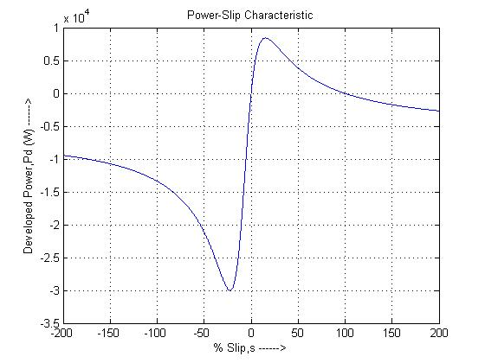

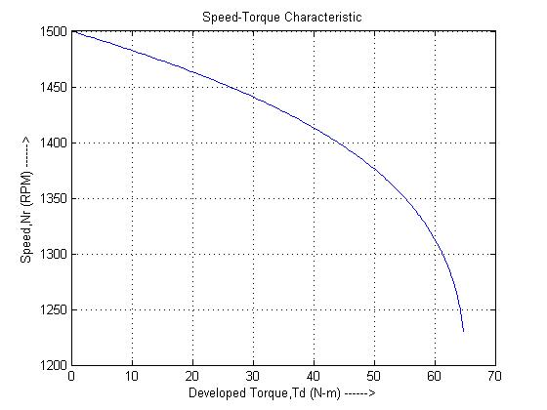

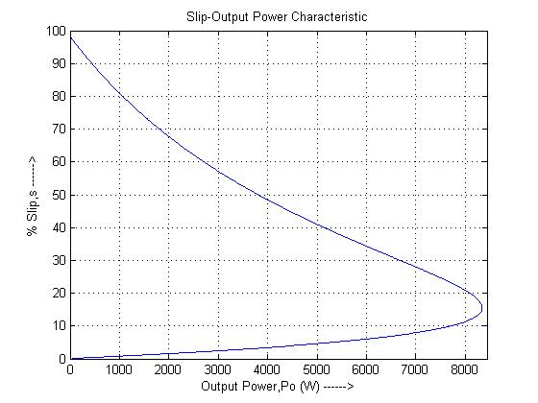

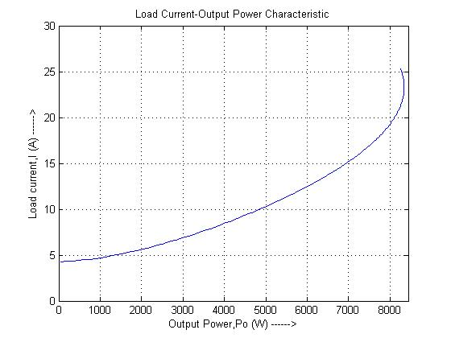

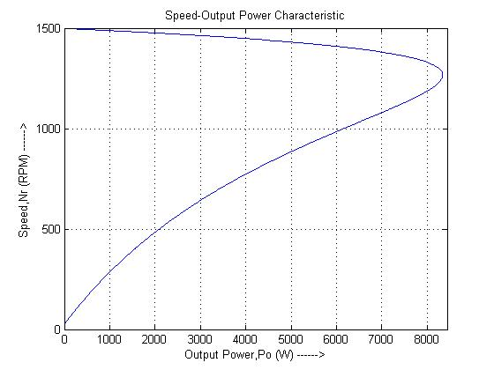

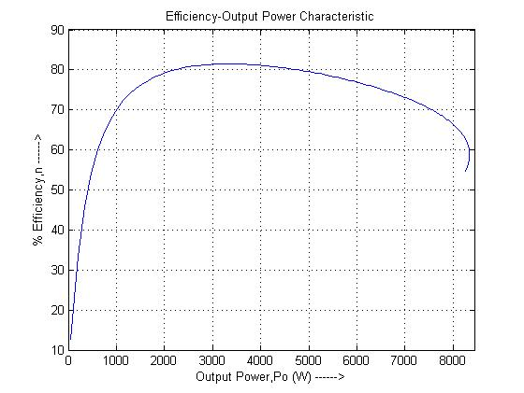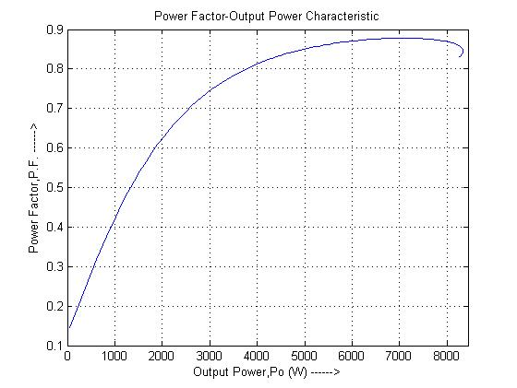

RESULT:

Hence the performance characteristics of a three phase induction machine are pre-determined using MATLAB, and its behavior is analyzed at various slips of operation.